Eagle Nest Elementary Middle School

Cell Phone Policy
2023/2024

Introduction
After carefully and thoughtfully reflecting upon ways to better support our students in the classroom, we have determined that cell phones and headphones are two items that are pulling all students away from authentically focusing on their classroom instruction. As we start this school year out fresh, we would like to share with you an upcoming change regarding our cellphone/headphone procedure that will take effect after the first few weeks of school. Starting on August 15, 2023, cell phones and/or headphones will only be allowed before and after school. Our expectation is that prior to home room and breakfast, students will put away their phone and/or headphones in their backpack or locker, remaining powered down or on silent and concealed until dismissal.
We understand that parents may have pressing issues or emergencies that arise during the school day, and for that reason, you are welcome and encouraged to contact the school secretaries so that we can relay a message or pull your students in if necessary. All students will continue to have access to their phone before and after school.

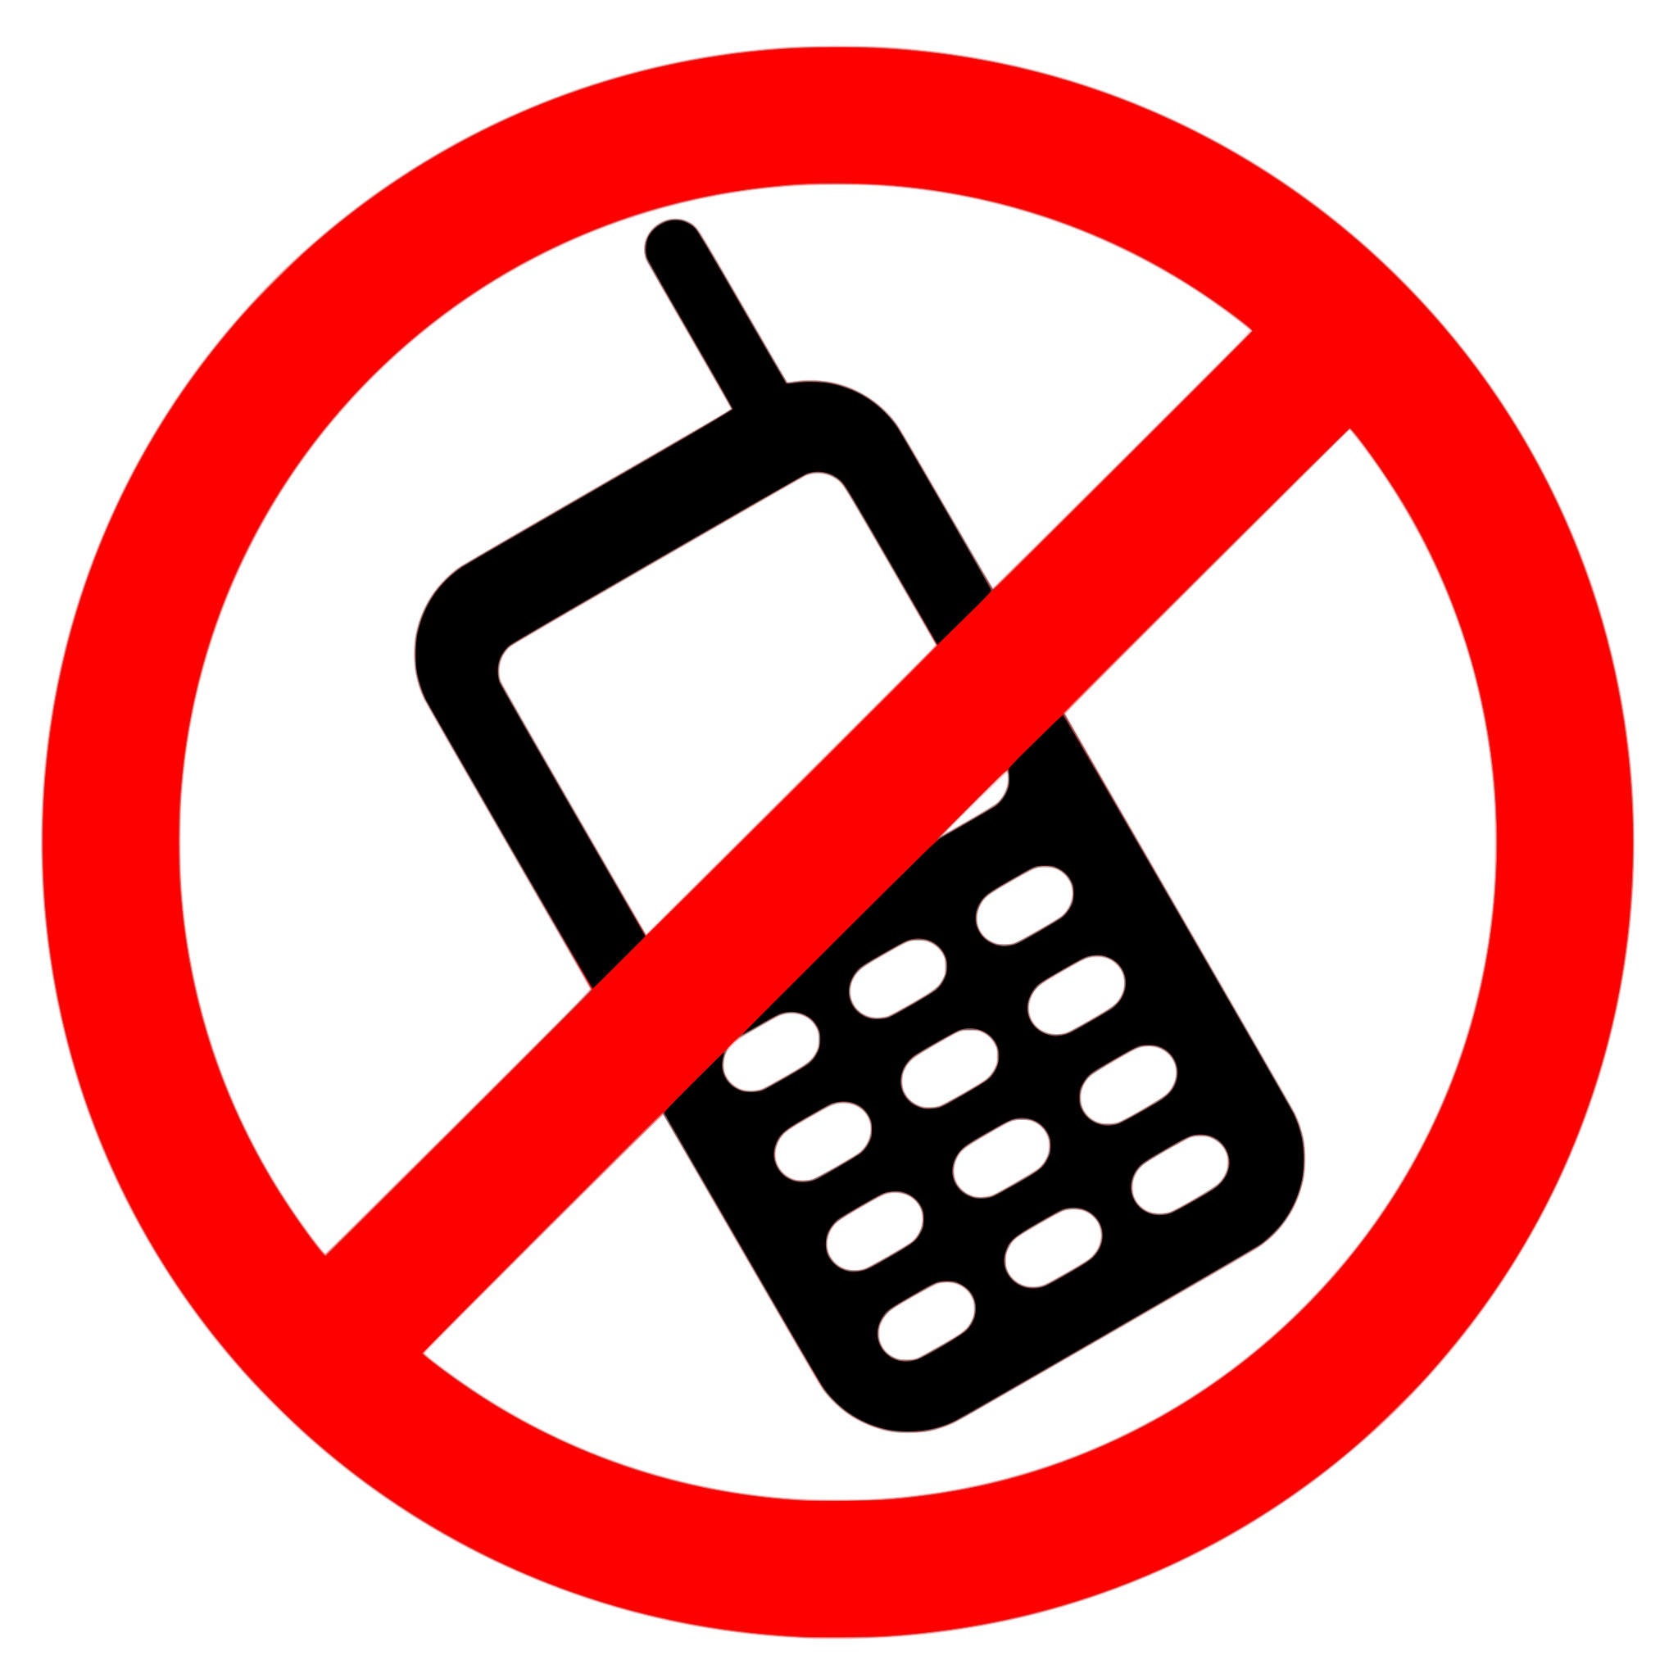

Guidelines
- Cell phones must be turned off and cannot be visible on campus,this includes the route bus, during the school day, including during all testing, unless they are being used for pre-approved whole class instructional purposes which must be approved by the teacher and principal before the activity begins.
- Placing a cell phone on vibrate or texting is not considered off and is prohibited.
- Headphones and other Bluetooth enabled devices (earphones/earbuds) are not permitted to be worn on campus.
- Cell phones are not to be used in the restrooms.
- Using a cell phone to record or view material is prohibited unless approved by the teacher or principal ahead of time.
- A staff member may confiscate a cell phone/electronic device if it rings, vibrates, is used for any reason without the teacher’s and principal’s permission, is visible anytime during class time, or if caught using it on campus during class time.
- Wristwatches with cell phone capabilities must follow the same guidelines as cell phones. If they are worn as a timepiece and not used for gaming, calling, or texting, they are ok. If it becomes a distraction for the student or teacher, the teacher may ask the student to place it in a secure location for the duration of this class time.

Inappropriate use or severe violations of these guidelines include but are not limited to:
- Electronic communication that contains inappropriate content, profanity, intimidation, or threats to others
- Sexting, which includes intentionally creating, producing, distributing, presenting, transmitting, posting, exchanging, disseminating, or possessing, through any computer or tidal media, any photograph or digitized image or any visual depiction of a person in any condition of nudity, or involved in any prohibited sexual act
- Academic dishonesty or cheating
- The use of cameras or recording features of cell phones and portable digital media devices in restrooms, locker rooms or for any use constituting an invasion of any person’s reasonable expectation of privacy
- Communicating in a way with outside groups or individuals to participate in violent acts or other inappropriate or unlawful activities on school property or at school-sponsored events
- Refusal to relinquish the phone to persons of authority upon request

Violation of these guidelines will result in the following:

First Offense:
- The cell phone will be confiscated and locked in the office. The phone can be picked up by the student at the end of the day.

Second Offense:
- The cell phone will be confiscated and locked up in the office. The phone can be picked up by the parent at their earliest convenience.

Third Offense:
- The cell phone will be confiscated and locked up in the office. The phone can be picked up by the parent and will pay a $15 fine.

Notes:
- The phone will be available for return the first day school is back in session if the return period ends during a school vacation or holiday.
- If parents must contact a student during the school day, the district requests they contact the school office for assistance.
- Students requiring the use of a phone during the school day must use a school phone available for student use with appropriate permission.
- Cimarron Municipal Schools are not responsible for lost, stolen, or damaged cell phones or electronic devices.
- State testing guidelines prohibit cell phones during state testing. Any violation of this guideline can result in the invalidation of the assessment and further disciplinary action according to the Cimarron Municipal Schools District Student Discipline Matrix under “Cheating or Plagiarism”.
- According to the Cimarron Municipal Schools District Student Discipline Matrix, failure to comply with a staff directive to turn in a cell phone will be considered “Insubordination, Defiance of Authority, or Showing Disrespect toward school personnel”.
- According to the Cimarron Municipal Schools District Student Discipline Matrix, any violation of these guidelines, which causes or involves a distraction or interruption of transportation, the instructional environment, or leads to the violation of other district rules or policies, the student will be subject to disciplinary action.

—------------------------------------------------------------------------------------------------------------------------------------------

Eagle Nest Elementary Middle School Cell Phone Policy Signature Page 23/24
Student Signature:_____________________________
Parent Signature:______________________________
Last name printed:_____________________________

